Lab 3 – DNS & The Kaminsky Attack
Shlomi Domnenko – 318643640

Lab Setup
- Cloned the Ubuntu 16.04 (not seed VM, but clean Ubuntu 16.04) virtual machine 3 times for: Attacker, Server, User.
- Then, I setup the IP of each machine to be exactly as described in the Lab Description by editing the ethernet settings:
  - DNS Server IP is: 10.0.2.16
  - DNS Attacker IP is: 10.0.2.17
  - DNS User IP is: 10.0.2.18
- Netmask is 255.255.255.0 and gateway is 10.0.2.1

DNS Server
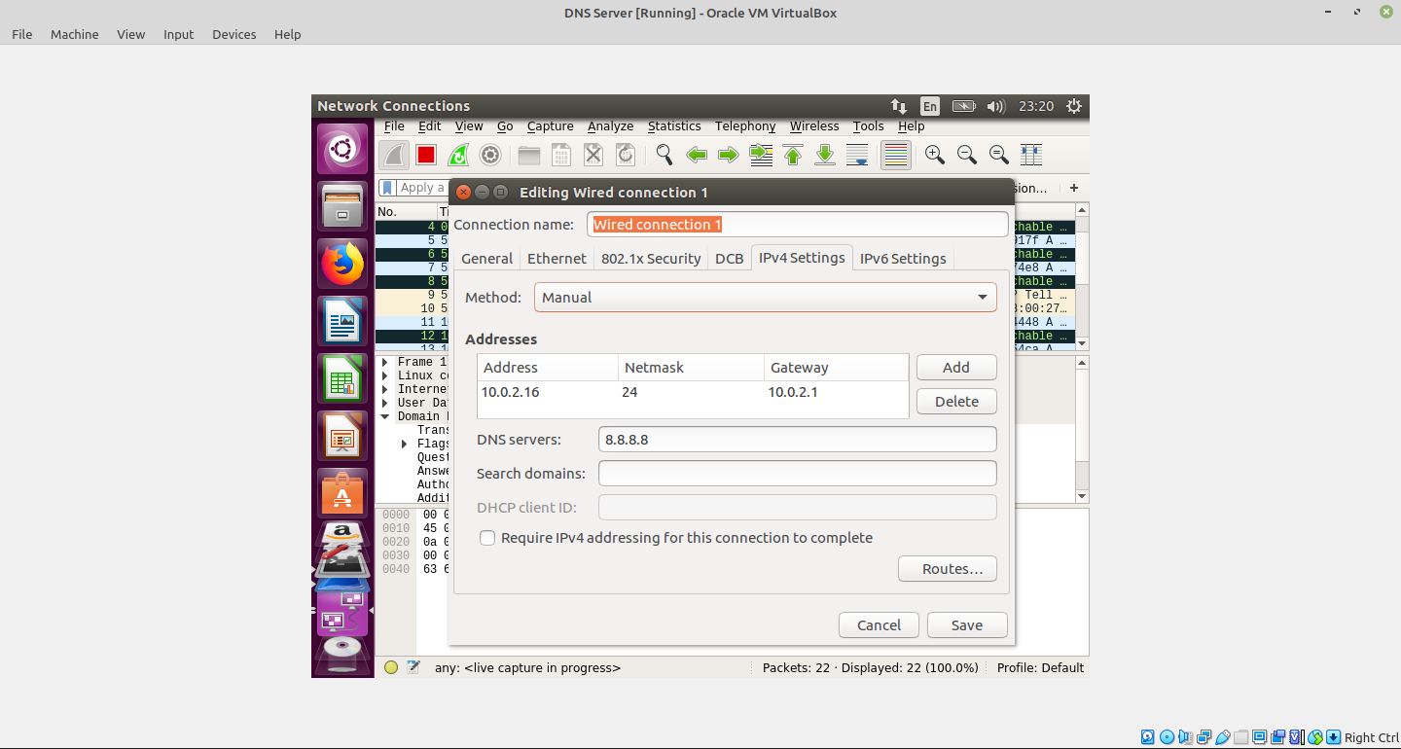Illustration 1: DNS Server Settings

User Machine
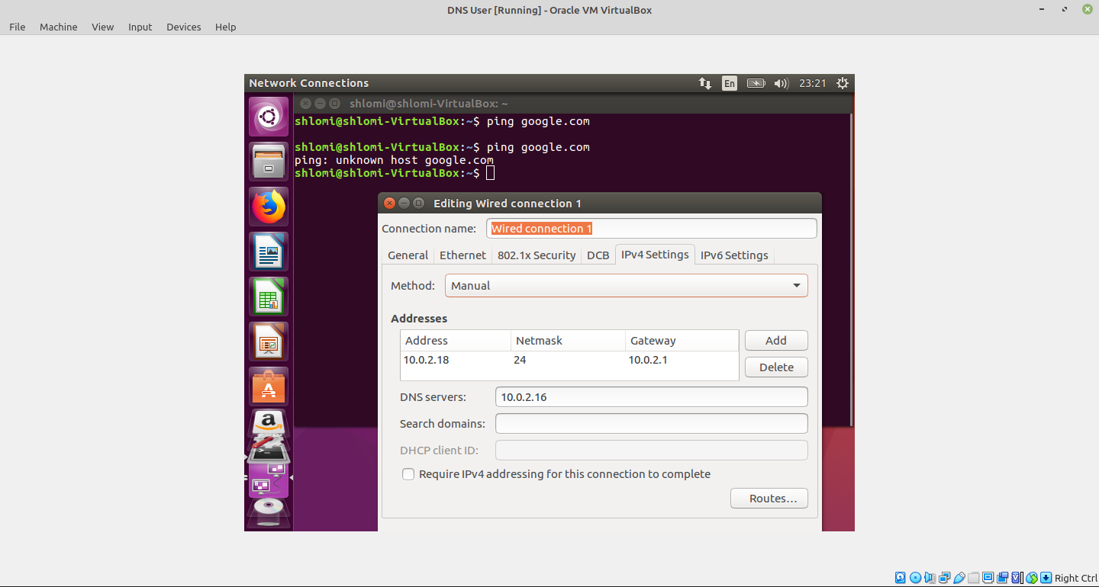Illustration 2: User network settings

Testing Environment
User pings google.com – asks the DNS server for that domain
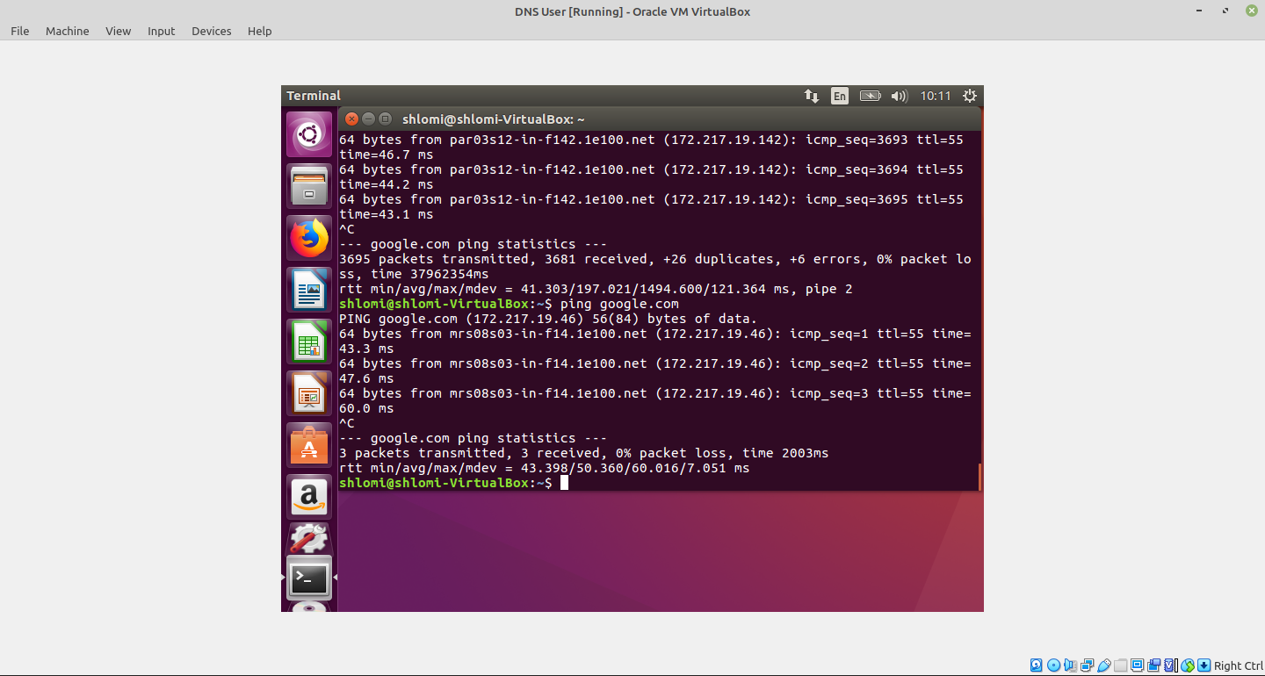
DNS Server sends IP:
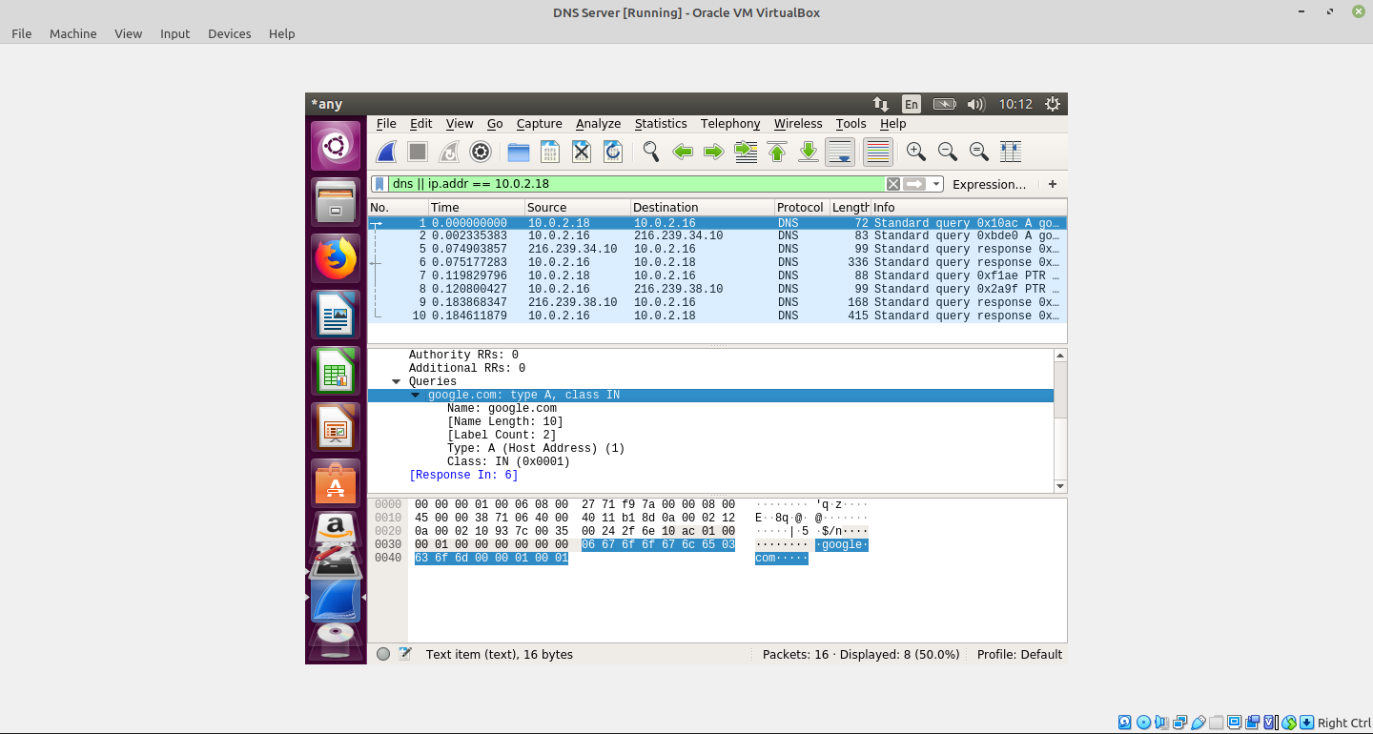
Notice the src.port of server: it’s 3333 and not random:
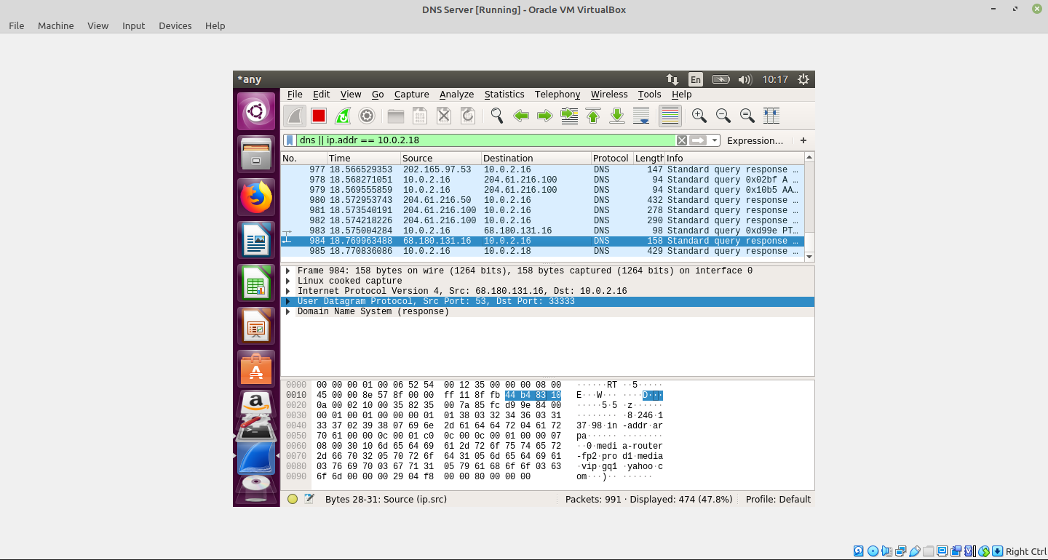
Dig is a DNS lookup tool. We test that tool for correct lab setup:
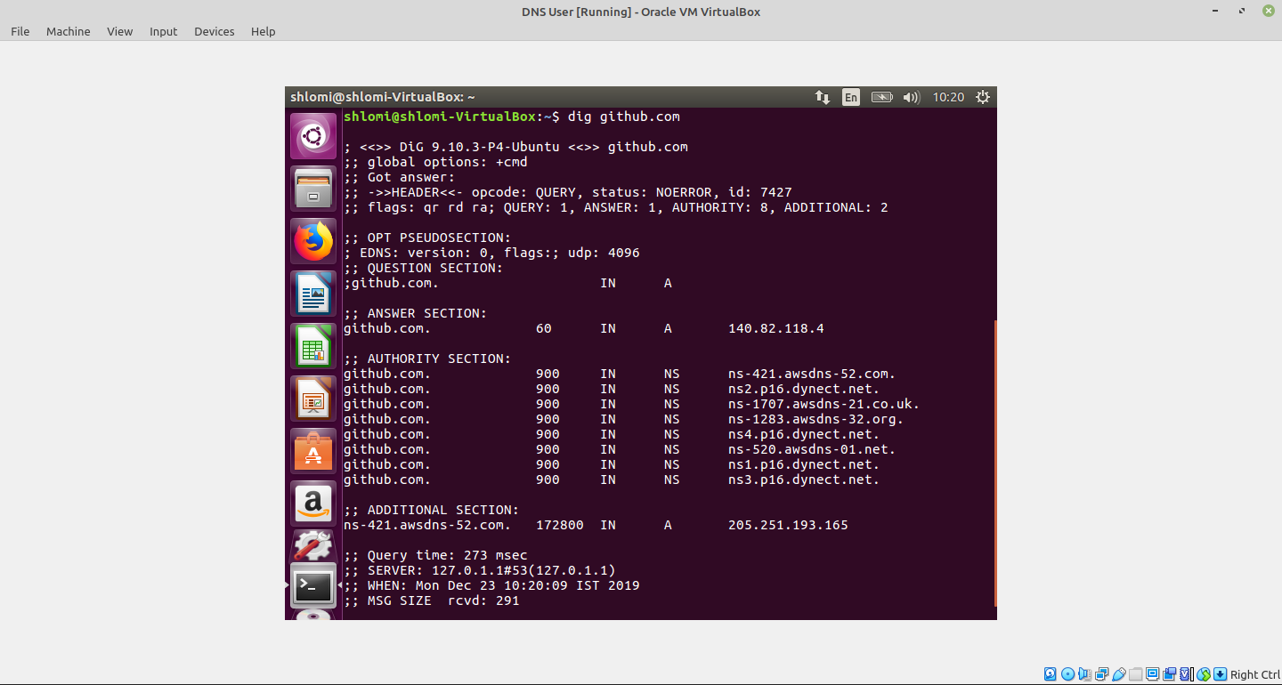
And at the server side:
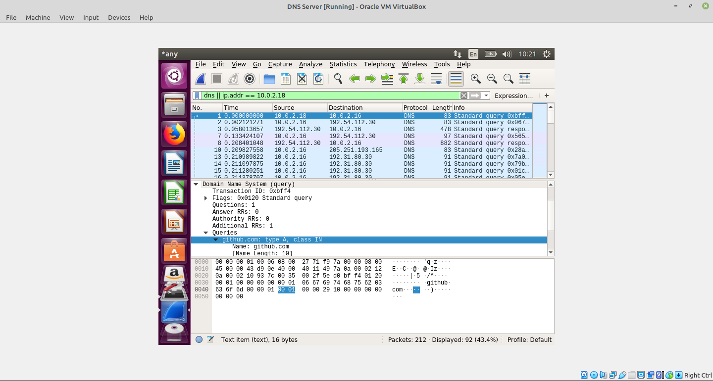
In conclusion my lab setup is working fine. Everything is setup correctly.

Lab Task 1

Attack Configuration
We setup now the attacker’s VM to use static ip, and the dns server
Ping google.com and it works.
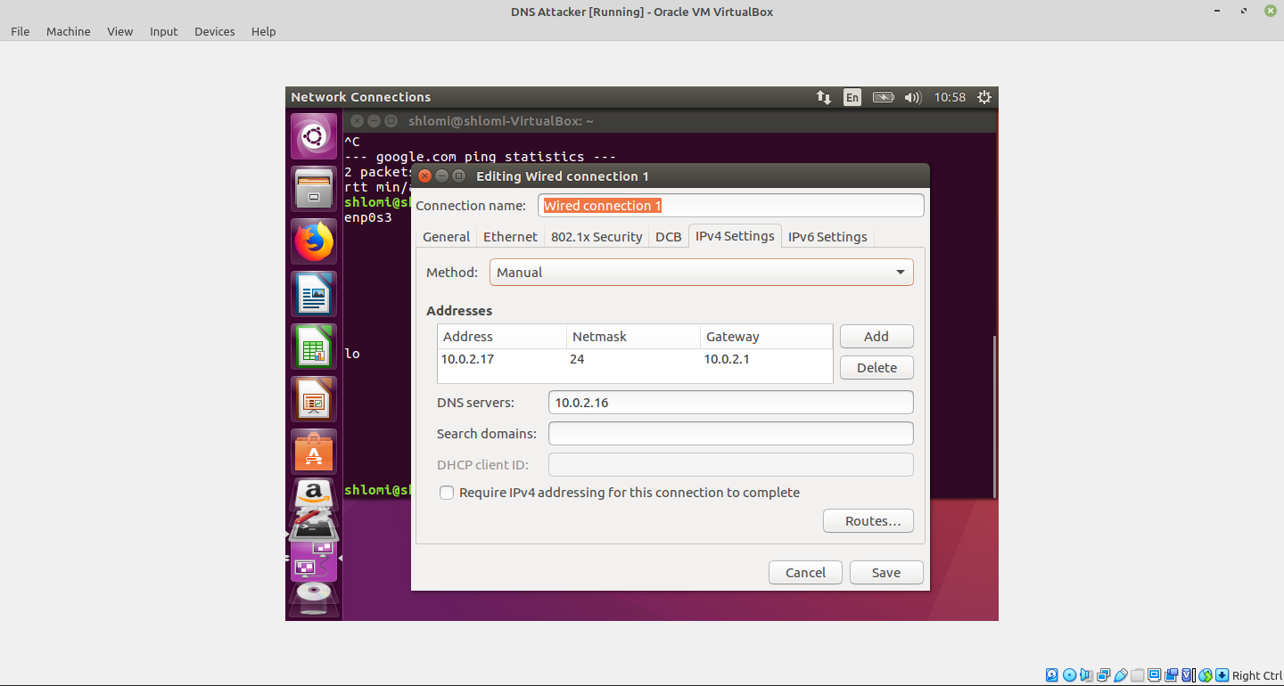Illustration 3: Attacker's network configuration

Lab Task 1.1 – Spoofing DNS request
Spoofing DNS request (with random sub-domain) is easy. My code:
#include <stdio.h>
#include <stdlib.h>
#include <time.h>
#include <string.h>
int main() {
int subdomainsize = 6;
int querysize = subdomainsize + strlen(".example.com");

srand(time(NULL)); //seed random

char query[querysize]; //this is the whole domain

for(int i = 0; i < subdomainsize; i++) {
query[i] = 'a' + (rand() % 26);
}

strcat(query, ".example.com");
printf("query = %s\n", query);

//execute the dig command
char command[50];
memset(command, 0, 50);
strcat(command, "dig ");
strcat(command, query);
system(command);
}

Lab Task 1.2 – Spoofing DNS Replies
In order to use the “udp.c” file, it requeires the “libnet” library. So I downloaded using:
$ sudo apt install libnet-dev
And compile the file:
$ gcc udp.c
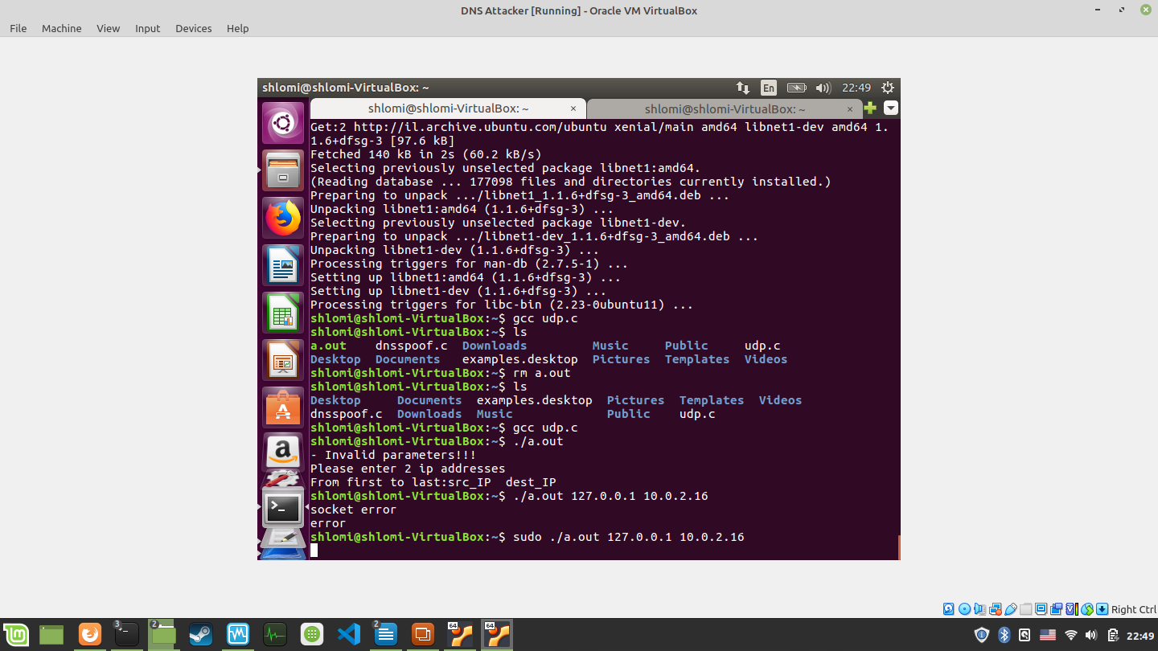Illustration 4: Running the udp.c script (no midification)
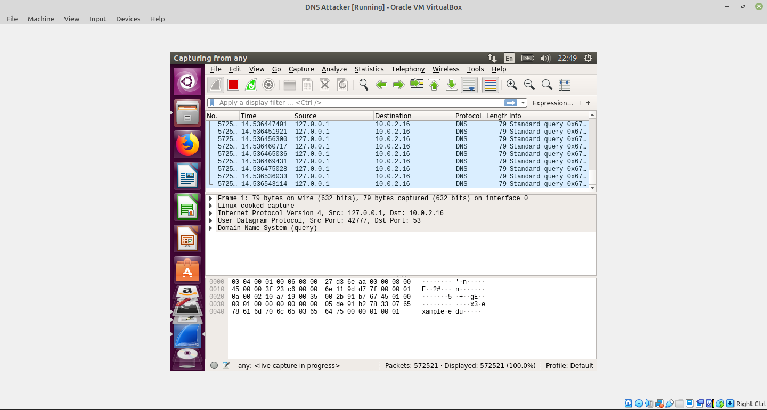Illustration 5: Wireshark the queries
In illustration 5 we can see that the attacker spoofs a lot of dns queries very fast. We can also see that for some DNS queries the DNS server sends the authorative server as response:
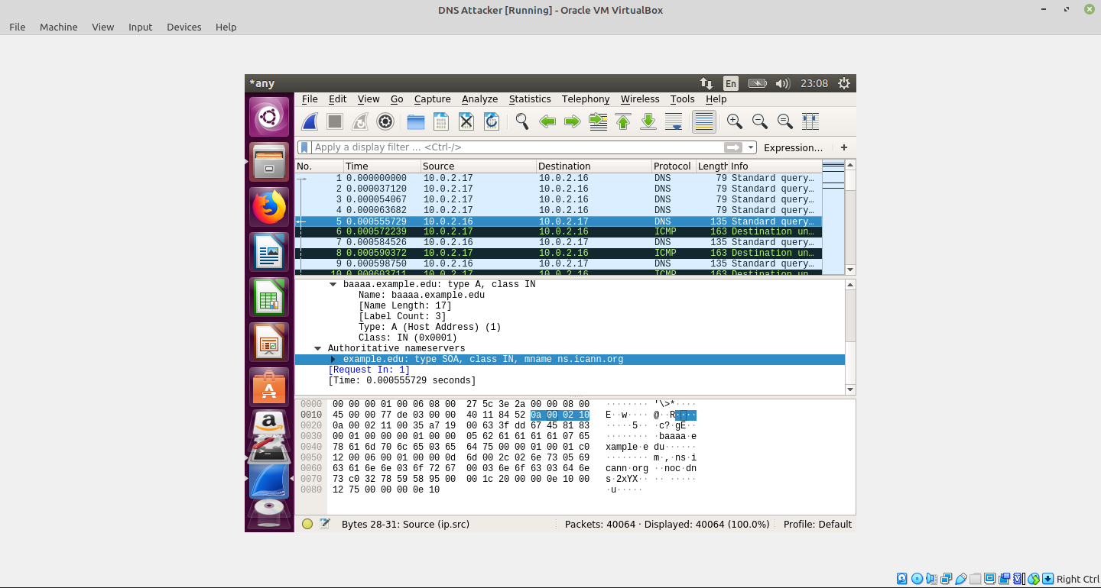Illustration 6: Authorative answer

Lab Task 2

